**Keystone**

organized as a group of internal services exposed on one or many endpoints. Many of these services are used in a combined fashion by the frontend, for example an authenticate call will validate user/project credentials with the Identity service and, upon success, create and return a token with the Token service.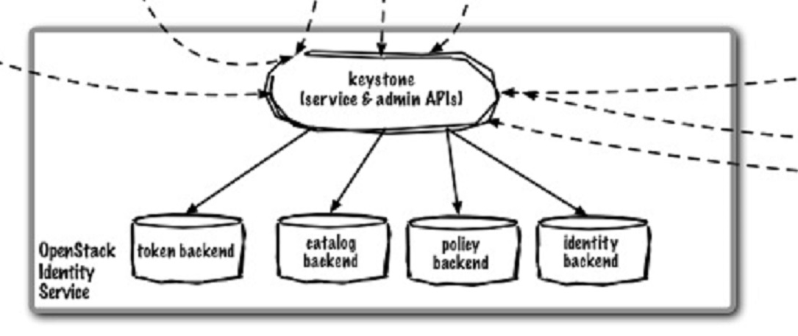

Python

CLI APIs Glance Horizon Nova

Swift

Cinder

Neutron Plugin

Neutron Server

keystone (service & admin APIs) – provides access to the keystone services via API

token backend – service validates and manages Tokens used for authenticating requests once a user’s credentials have already been verified.

catalog backend – service provides an endpoint registry used for endpoint discovery.

policy backend –  service provides a rule-based authorization engine and the associated rule management interface.

identity backend - service provides auth credential validation and data about Users, Groups, Projects, Domains and Roles, as well as any associated metadata. In the basic case all this data is managed by the service, allowing the service to manage all the CRUD associated with the data.

In other cases, this data is pulled, by varying degrees, from an authoritative backend service. An example of this would be when backending on LDAP. See LDAP Backend below for more details. (ex AD)

Federation

<http://docs.openstack.org/developer/keystone/configure_federation.html>